Real-time Market Data Forecasting
Design Document
C-DAC, Bangalore
Version 1.0
27-01-2025

Prepared By:
Suchandra Siripuram
Agna Sebastian
Ajitesh Sharma
David D M
Himansh Gupta

Contents
Real-time Market Data Forecasting 1
1.0 Introduction 5
1.1 Purpose 5
This document outlines the architectural and design details of the Real-time Market Data Forecasting system. It provides a blueprint for developers to implement functionalities such as real-time stock dashboards, technical indicators, and 3-day forecasts using Prophet. Scope 5
Intended Audience 5
The document is intended to be read and understood by all the design, development, and testing teams. It should be referred to at all stages of the project lifecycle. 5
1.2 References 5
2.0 Acronyms, terms and definitions 5
3.0 Assumptions and constraints 5
• The application follows an API-based development approach, requiring user subscription to access the provided functionality. 5
• The system assumes that real-time market data will be available through third-party data providers. 5
• The machine learning models used for forecasting are trained on historical data, and their accuracy depends on the quality of the data. 5
• The system is constrained by the computational resources available for real-time data processing and forecasting. 5
4.0 Basic Design approach 5
5.0 Risks 6
6.0 System overview 6
7.0 Architecture Design 6
8.0 Data Design 6
9.0 Component Design 7
Component 1: Data Ingestion 7
• Description: This component is responsible for collecting real-time market data from various sources such as stock exchanges, financial news, and social media. 7
• Process: 7
1. Connect to data sources. 7
2. Collect real-time data. 7
3. Store the data in the database. 7
• Activity Diagram: 7
Component 2: Machine Learning Forecasting 7
• Description: This component uses machine learning models to analyze the processed data and generate market forecasts. 7
• Process: 7
1. Load historical data. 7
2. Train the machine learning model. 7
3. Generate forecasts based on real-time data. 7
10.0 Interface Design 7
Provide all the GUI layouts for each interface in the application. 7
• Dashboard Interface: Displays real-time market data and forecasts. 7
• API Explorer Interface: Allows users to interact with the forecasting APIs. 7
11.0 Any Specific Design Considerations 9
• The system is designed to handle a limited number of simultaneous processing requests for the services provided by the API. Although the design considers upscaling, testing and upgradation are not envisaged in the initial phase. 9
• The APIs developed shall be functionally tested with required security controls through the API gateway. 9
• The API services are provided for consumption through a web-based interface. 9
• The API is exposed to users in the form of an API Explorer and an Administrative Dashboard. 9
• The API services are generic domain-specific implementations and can be consumed by any other larger system with the API working as subsystem components. 9
12.0 Design Test 9
13.0 Cross Reference with System Requirement Specification 9
/ingest 9

Introduction
Introduction to the project.

Purpose

This document outlines the architectural and design details of the Real-time Market Data Forecasting system. It provides a blueprint for developers to implement functionalities such as real-time stock dashboards, technical indicators, and 3-day forecasts using Prophet.
Scope
The system includes:
- Real-time stock price visualization (candlestick/line charts).
- Technical indicators (SMA, EMA).
- Prophet-based forecasting of percentage changes.
- Compatibility with Nifty 50 companies.

Intended Audience

The document is intended to be read and understood by all the design, development, and testing teams. It should be referred to at all stages of the project lifecycle.

References
- Functional Requirement Specifications (FRS)
- Market Data Analysis and Forecasting Requirements Document

Acronyms, terms and definitions
  - SMA: Simple Moving Average
  - EMA: Exponential Moving Average
  - FRS: Functional Requirement Specification

Assumptions and constraints

The application follows an API-based development approach, requiring user subscription to access the provided functionality.

The system assumes that real-time market data will be available through third-party data providers.

The machine learning models used for forecasting are trained on historical data, and their accuracy depends on the quality of the data.

The system is constrained by the computational resources available for real-time data processing and forecasting.

Basic Design approach
  - Modular Architecture: Separates data fetching, processing, visualization, and forecasting.
  - API Integration: Uses yfinance for real-time data.
  - Structured Workflow:
    - User selects parameters (company, time period).
    - Data fetched and processed.
    - Visualizations and forecasts generated.

Risks
- Data Privacy and Security: Handling sensitive market data may pose risks related to data privacy and security.
- Model Accuracy: The accuracy of the forecasting models depends on the quality of the input data, which may vary.
- Real-time Processing: Delays in real-time data processing could affect the timeliness of forecasts.

System overview
The Real-time Market Data Forecasting system is designed to provide real-time analysis and forecasting of market data using machine learning models. The system ingests real-time market data from various sources, processes it, and generates forecasts that can be accessed through a web-based interface or API.

Architecture Design
The architecture diagram is prepared to fulfill the requirements as per the FRS.
Explanation of Components in Architecture Diagram
- Data Ingestion Layer: Responsible for collecting real-time market data from various sources.
- Data Processing Layer: Processes the ingested data and prepares it for analysis.
- Machine Learning Layer: Contains the forecasting models that analyze the processed data and generate predictions
- API Gateway: Exposes the forecasting functionality to external users through APIs.
- User Interface: Provides a web-based interface for users to interact with the system and view forecasts.

Data Design
The data is stored in a relational database. The database tables are divided into master tables (prefixed by m), logs (prefixed by l), and transaction tables (no prefix).
Database ER Diagram
Database Tables
Table Market Data
Explain what is this table used for

Idx (Primary Key) | Field Name | Data Type | Description
1 | id | INT(PK) | Unique identifier for the record
2 | timestamp | DATETIME | Timestamp of the market data
3 | Symbol | VARCHAR | Stock symbol
Indexes (Foreign Keys)
4 | price | FLOAT | Current market price

Component Design

Component 1: Data Ingestion

Description: This component is responsible for collecting real-time market data from various sources such as stock exchanges, financial news, and social media.

Process:

Connect to data sources.

Collect real-time data.

Store the data in the database.

Activity Diagram:

Component 2: Machine Learning Forecasting

Description: This component uses machine learning models to analyze the processed data and generate market forecasts.

Process:

Load historical data.

Train the machine learning model.

Generate forecasts based on real-time data.

Interface Design

Provide all the GUI layouts for each interface in the application.

Dashboard Interface: Displays real-time market data and forecasts.

API Explorer Interface: Allows users to interact with the forecasting APIs.

Stock (Stock_ID, Stock_Name, Ticker_Symbol)
|
|-- Stock_Price_History (Record_ID, Stock_ID, Datetime, Open_Price, Close_Price, High_Price,
Low_Price, Volume)
|
|-- Technical_Indicators (Indicator_ID, Stock_ID, Datetime, SMA_20, EMA_20)
|
|-- Forecast (Forecast_ID, Stock_ID, Datetime, Forecasted_Pct_Change, Confidence_Interval_Lower, Confidence_Interval_Upper)

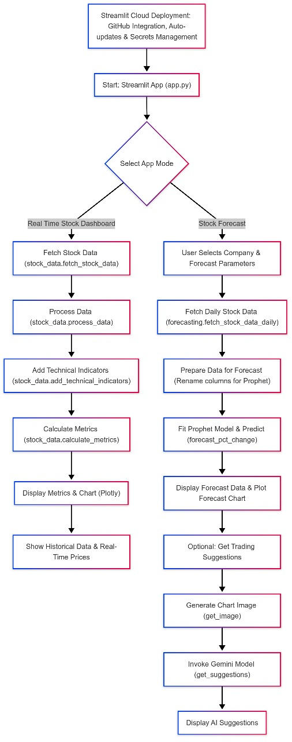

Any Specific Design Considerations

The system is designed to handle a limited number of simultaneous processing requests for the services provided by the API. Although the design considers upscaling, testing and upgradation are not envisaged in the initial phase.

The APIs developed shall be functionally tested with required security controls through the API gateway.

The API services are provided for consumption through a web-based interface.

The API is exposed to users in the form of an API Explorer and an Administrative Dashboard.

The API services are generic domain-specific implementations and can be consumed by any other larger system with the API working as subsystem components.

Design Test
  - Unit tests for data fetching/processing.
  - Integration tests for end-to-end workflows.

Cross Reference with System Requirement Specification

System Requirement Specification Features
API's Developed | Requirements | Adherence/Limitations
COMPONENT NAME
Real-time Data Ingestion | /ingest | Meets the FR completely

Appendix A/B/C – Appendix Name

Details of appendix

